**Mapping Geographical Accessibility to Primary Health Facilities in Tanzania Mainland and Zambia**

**Investigators**: Herieth Mboya , Oscar Lugumamu, Yasini Kokoda ,Phoibe Keu

Github Repo: [ECR Final Project](https://github.com/Kokoda95/ECR_Final_Project)

**1.0 Introduction**

Primary Healthcare is the backbone of an efficient and effective health delivery system. It serves as the entry point and first contact for most health issues . From this level is where coordination of care to other levels of care also happens. Strong Primary health care systems also lower the overall health expenditure but provide preventive and promotive services.

Hospitalization rates for Ambulatory care sensitive conditions (ACSC) serve as a widely accepted proxy for the accessibility, quality, and continuity of primary health services. Lower rates suggest that PHC is effectively preventing, managing, or appropriately controlling these conditions. Ambulatory Care Sensitive Conditions (ACSCs) are illnesses for which effective and timely primary health care (PHC), both preventive and ongoing management, can prevent the need for hospitalization . Examples include chronic diseases like diabetes, asthma, hypertension, and acute conditions such as urinary tract infections or pneumonia.

Access to healthcare is subject to spatial and aspatial factors.These include availability , accessibility , affordability , acceptability and accommodation.The first two dimensions;availability and accessibility ,are spatial in nature, focusing on the distribution and proximity of healthcare services. Availability refers to the presence of healthcare services in relation to the population's needs, while accessibility pertains to the ease with which individuals can reach these services, considering factors like distance, transportation, and travel time.

Owing to the heterogeneity of facility distribution relative to population , there exists global disparities in accessibility. Low and Middle Income Countries (LMICs) face persistent challenges in ensuring equitable access to primary health facilities. In many LMICs, a significant portion of the population lives within 2 hours from the nearest health facility. This physical distance, combined with poor road infrastructure, limited public transport, and challenging terrain, makes it difficult for individuals, especially in rural and remote areas, to reach timely care. These barriers often lead to delays in treatment, lower healthcare utilization, and worse health outcomes, particularly among vulnerable groups such as women, children, and the elderly (Ouma et al., 2018; WHO & World Bank, 2017)

In many parts of Africa, especially in rural and remote areas, physical access to health facilities remains limited.Over 60% of Africa’s population live more than 5 kilometers from the nearest health facility, creating serious barriers to timely care. These challenges often translate into poor health outcomes, delayed treatment, and increased healthcare costs (Weiss et al, 2020 & WHO, 2021) .

Between 2001 -2002 and 2018, Zambia saw a significant improvement in two key healthcare access barriers:

* **Distance to health facility** (“a big problem”): dropped from **45.5%** in 2001–02 to **28.8%** in 2018.
* **Having to take transport**: declined from **47.3%** in 2001–02 to **24.5%** in 2018.

Halving the share of people citing distance or transport issues reflects the **expansion of health facilities**, particularly via rural health posts and centers, and modest improvements in rural transport infrastructureHowever, even in 2018, **over a quarter** of the population still reported these barriers.

UN member states have committed to achieving Universal health Coverage by 2030. A bold ambition where all people have access to the full range of quality health services they need, without financial hardship. Tanzania Mainland and Zambia have made progress in expanding their primary healthcare networks but significant geographic and infrastructural inequalities remain..

To align with the 2030 goals, it is essential to assess accessibility and progress made.While access to care is broad , geographical accessibility assessment is a stepping stone to understanding the current state . We map accessibility to Primary health care facilities and assess the population coverage for Tanzania and Zambia .

**1.1 Statement of the problem**

Primary Health Care is the key to achieving Universal Health Coverage by 2030, that emphasizes primary health facilities should be accessible to all, especially to remote areas. However, countries like Tanzania Mainland and Zambia faced disparities to geographical accessibility from household to primary health facilities.

Many studies have focused on exploring healthcare access in Tanzania and Zambia, many narrowly on geographic distance and often rely on simplified methods like straight-line (Euclidean) distance which does not reflect the real travel conditions experienced by patients. These methods overlook road conditions as well as barriers such as Landcover and Elevation which significantly impede travel.They also don't consider the mode of travel (motorized vs walking).

This study aims to assess geographical accessibility using sophisticated GIS tools that can be used in health system planning.

**1.2 Main Objective**

To map accessibility to primary health facilities in Tanzania Mainland and Zambia

**1.2.1 Specific Objective**

* To map the distribution of primary health facilities in Tanzania Mainland and Zambia .
* To map the travel time to health facilities by motorized and walking in Tanzania Mainland and Zambia .
* To estimate the proportion of population living within different travel times in Tanzania Mainland and Zambia

**2.0 Approach/Methodology**

This section outlines the approach and methodology adopted to estimate physical accessibility to primary health care (PHC) facilities in Tanzania Mainland and Zambia. It covers the key data sources, tools used, and analytical steps from data preparation to travel time modeling using geospatial techniques.

**2.1 Data Sources**

We sourced high-resolution geospatial and health datasets from reputable global and national sources. Data Sources included;

| **Tool** | **Source** | **Purpose** | **Resolution and Extent** |
| --- | --- | --- | --- |
| Friction Surfaces | Malaria Atlas R package | The time cost (in minutes) to cross each raster cell depending on transport mode and terrain | 1km x 1Km for Zambia and Tanzania Mainland |
| Health Facility Locations | Tanzania Mainland & Zambia Master Facility Lists (2024) | Identifying PHC facility locations | Zambia and mainland Tanzania |
| Population Raster | Humanitarian Data Exchange | Subgridden population rasters projected from the national census provided by World Pop. | 1km x 1Km for Zambia and Tanzania Mainland |

### **2.2 Data Analysis**

The data analysis process involved several stages, from preprocessing to travel time and population coverage and interpretation. The goal was to estimate physical accessibility to primary health facilities in Tanzania Mainland and Zambia using travel time as the main metric.

#### **2.2.1 : Data Preparation and Cleaning**

We also cropped the Population Raster to match the extent of mainland Tanzania. We filtered health facilities to include only primary health facilities (Dispensaries, Health centres and District hospitals). Latitude and longitude coordinates were verified and cleaned to ensure only health facilities located within the geographical boundaries of the country. Out of 13,009 facilities listed in the Tanzania mainland health facility registry, 10088 were identified as primary health facilities and 9751 had the geolocation information. Moreover, 136 facilities laid out of the country were excluded, resulting in 9615 facilities in the final dataset for Tanzania.

For Zambia, there were 3478 primary health facilities, 82 without geolocation information and 65 laid out of the country which were also excluded from the analysis, resulting in 3327 facilities in the final dataset.

#### **2.2.2 : Friction Surface extraction**

The friction surfaces were extracted from the Malaria Atlas R package.They were developed for walking and motorized travel and we extracted both for every country . These Friction Surfaces were developed in 2018 by Weiss et al and used roads network, elevation and landcover .

Although some roads have been built between 2018 and 2025 , we used this dataset to reduce computational overhead. The added roads, while significant, are concentrated in few urbanized areas and their absence has a modest effect on broad-scale travel-time models.The extracted friction surfaces were in two dimensional and were geocorrected to fit the three dimensional nature of the earth's sphere.

#### **2.2.3 : Travel Time Calculation using Friction Surface from Malaria Atlas**

A cost-distance analysis was performed by using the geolocated health facilities. This calculated travel time from each raster cell to the nearest PHC facility.Separate scenarios were calculated for walking and motorized travel.

#### 

#### **2.2.4 : Population Accessibility Estimation**

To gauge the population coverage we overlaid travel time raster with population raster data. This was followed by calculating the proportion of the population within set travel time thresholds for both walking and motorized travel. These set times included under 10, 30 and 60 minutes.

**3.0 Results**

**3.1 Distribution of Primary Health Facilities**

This section shows how primary health facilities are spread across Tanzania and Zambia. On average, each basic health facility serves between 7,000 and 10,000 people. Figure 1 and Figure 2 show how many health facilities exist per 10,000 people in different parts of each country. In both countries, the number of health facilities per population varies by region. In Tanzania, the western areas have fewer health facilities compared to the number of people. In contrast, some parts of the north, like Mwanga District in Kilimanjaro Region and the south such as Makete and Ludewa Districts in Njombe Region have more health facilities for their population. In Zambia, regions like Lusaka Province also have a higher number of health facilities per 10,000 people compared to other parts of the country

**Figure 1: Distribution of HF in Tanzania Figure 2: Distribution of HF in Zambia**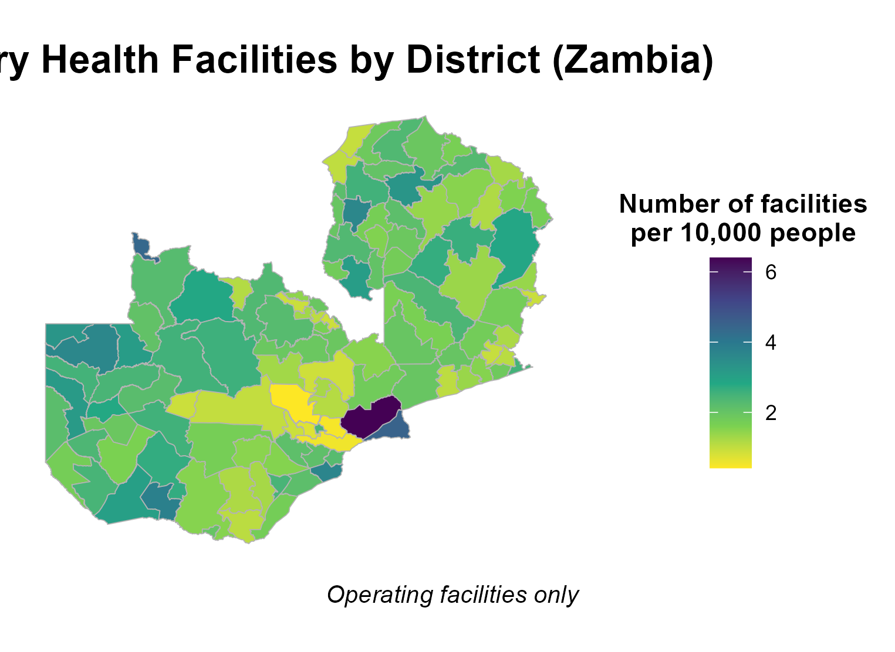

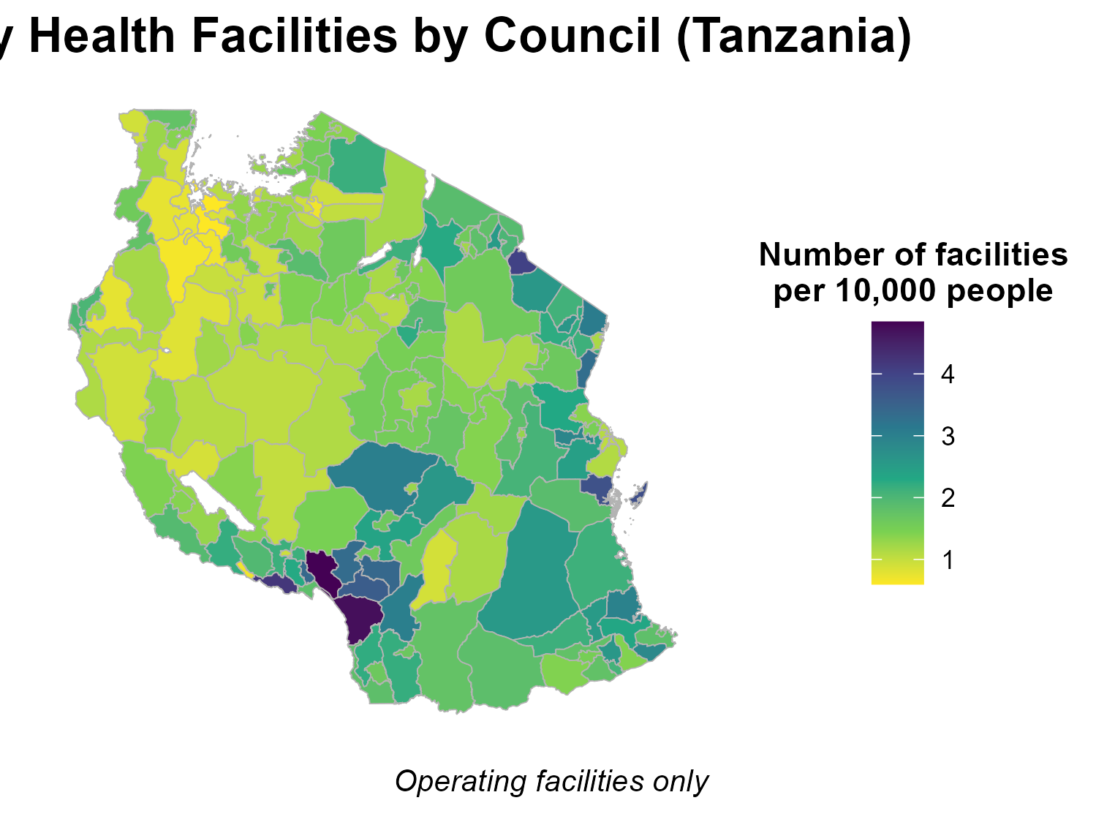

**3.2 : Travel time to health facilities in Tanzania Mainland and Zambia .**

| Figure 3: Travel time to health facilities | |
| --- | --- |
|

**3.3.1 : Population Coverage in Different travel times**

**3.3.1 : Population Coverage in Different travel times in Walking**

| **Time travel** | **Population mainland Tanzania N(%)** | **Population mainland Zambia N(%)** |
| --- | --- | --- |
| Under 10 minutes | 9196529(13.6) | 1575761(7.3) |
| Under 30 minutes | 36957385(54.8) | 8778596(40.7) |
| Within 1 hour | 54583141(81) | 14046043(65.1) |
| Over 1 hour | 12,810,339(9) | 7,538,260(34.9) |

**3.3.1 : Population Coverage in Different travel times in Motorized**

| **Time travel** | **Population mainland Tanzania N(%)** | **Population mainland Zambia N(%)** |
| --- | --- | --- |
| Under 10 minutes | 51565658(76.5) | 15004473 (69.5) |
| Under 30 minutes | 61464353(91.2) | 19579483(90.7) |
| Within 1 hour | 65107264(96.6) | 20794693(96.3) |
| Over 1 hour | 2,286,216(3.4) | 789,610(3.7) |

**4.0 Discussion**

We aimed to map…

It was found that 81% of the population in Tanzania lives within an hour of walking to the nearest health facility. This is high when contrasted to 65% in Zambia .While this is remarkable and shows progress . These metrics still fall short of The World Health Organization (WHO) recommendation. It is recommended that no individual should be more than one hour away from essential health services.Travelling more than one hour is associated with worse outcomes across different demographics.Increasing the population which can access facilities within an hour .

In Tanzania 84.3% of the population access healthcare services by non-motorized form of transport. Hence , despite broad motorized coverage, true accessibility remains limited by transport modality . To enhance health equity and reduce travel-related disparities, expanding access-especially improving non-motorized and active transport infrastructure-will be essential.

This estimation relies on settlement location as the point from which individuals seek healthcare. This approach overlooks the fact that individuals may seek care from places of daily work or other locations, leading to inaccuracies in assessing true access.

Urban centres have more facilities and better accessibility owing to the presence of better infrastructures and more facilities per population. This has been established and reflects in poorer health outcomes in rural vs urban areas.

There is a need to expand research under different weather conditions, incorporate service availability, and compare accessibility during day and night to obtain a more comprehensive understanding of geographic healthcare access. This will also highlight areas that could become underserved under different conditions. Addressing these gaps is crucial for achieving Universal Health Coverage by 2030 and ensuring equitable access to quality healthcare for all populations.

**5.0 Conclusion and recommendation**

**6.0 References**

1. Weiss, D. J., et al. (2020). A global map of travel time to cities to assess inequalities in accessibility in 2015. Nature, 553, 333–336
2. WHO & World Bank. (2017). Tracking Universal Health Coverage: 2017 Global Monitoring Report.
3. Guagliardo, M.F. (2004). Spatial accessibility of primary care: concepts, methods and challenges. International Journal of Health Geographics, 3(3).
4. (IntechOpen). Healthcare Accessibility: Metrics, Assessment, Policies, and Barriers. IntechOpen. [Details from IntechOpen publication; citation not fully available via search.]
5. Petricola, S., Reinmuth, M., Lautenbach, S., et al. (2022). Assessing road criticality and loss of healthcare accessibility during floods: the case of Cyclone Idai, Mozambique 2019. International Journal of Health Geographics, 21:14.
6. Husdal, A. (n.d.). Network analysis – raster versus vector – A comparison. husdal.com. [Specific publication not retrieved; assumed blog/tutorial.]
7. Husdal, A. (n.d.). How to create accessibility to anything. husdal.com. [MAP-developed guide.]
8. Weiss, D.J., Nelson, A., Gibson, H.S., et al. (2018). A global map of travel time to cities to assess inequalities in accessibility in 2015. Nature, 553(7688), 333–336.
9. Weiss, D., Lieber, A., Kamath, C., Gabrilovich, E., Gligoric, K., et al. (2020). Global maps of travel time to healthcare facilities. Nature Medicine.
10. Exemplars in Global Health. (n.d.). Pathway 3: How did Zambia improve community access to primary health care? What did Zambia do?
11. The Borgen Project. Examining the Health Care System in Zambia.
12. Husdal, A. (n.d.). Corridor Analysis – A timeline of evolutionary development. husdal.com.
13. Husdal, A. (n.d.). How to make a straight line square. husdal.com.
14. Ebener, S., Stenberg, K., Brun, M., et al. (2019). Approaches to measuring and modelling physical access to health care in low- and middle-income countries using geospatial data: A scoping review. BMJ Global Health, 4(1), e001011.

**Comms plan:** Disseminate findings around the ECR Symposium, IASC event, and high-impact journal publication by tailoring content to scientists and stakeholders.